## **Unit and Integration Test Plans**

<Project Lighthouse>

My testing will be actual users testing my application as well as myself. I am building this application for specific people in my life, so I am going to have them test it for me, get some feedback and let me know how I can make it better. On top of that I will, of course, be testing it myself since the people I have in mind aren’t very technically skilled in the area of computers.

|  |
| --- |
| Test Tools |
| 1 -Android Studio |
| 2 – Android Phone (running API 31) |

|  |
| --- |
| COMPONENT TESTING |

|  |  |  |  |  |  |  |  |  |  |  |  |  |  |  |  |  |  |  |  |  |  |  |  |  |  |  |  |  |  |  |  |
| --- | --- | --- | --- | --- | --- | --- | --- | --- | --- | --- | --- | --- | --- | --- | --- | --- | --- | --- | --- | --- | --- | --- | --- | --- | --- | --- | --- | --- | --- | --- | --- |
| COMPONENT: | | | Journal Entry Scrolling and Button Click | | | | | | |  | | | Name of Developer: | | | | | | | | | Kurt Newcomb | | | | | | | |  | |
|  | |  | |  |  | |  | |  | | |  | | | |  |  |  | | | | | | | |  |  |  | | | | | | | |  |
|  | |  | |  |  | |  | |  | | |  | | | |  | Name of Reviewer: | | | | | | | Amr Elchouemi | | | | | | | | | |  |
|  | |  | |  |  | |  | |  | | |  | | | |  |  |  | | | | |  | | | |  |  | | |  | | |
| Component Test Checklist | | | | | | | | | | | | | | | | | | | | | | | | | | | | | |
| N/A | | Pass | |  | | | | | | | | | | | Reviewed by Developer | | | | | Comments | | | | | | | | | |
| Functionality | | | | | | | | | | | | | | | | | | | | | | | | | | | | | |
| Journal Entry | | Pass | |  | | | | | | | | | | | Kurt | | | | Journal Entry Menu is fully functional | | | | | | | | | | |
| Timeline | | Pass | |  | | | | | | | | | | | Kurt | | | | Viewing the timeline and opening up a dialog box with details of the journal entry from it is complete functional. | | | | | | | | | | |
| Affirmations | | Pass | |  | | | | | | | | | | | Kurt | | | | Every component of the Affirmations menu is functional, except for the notifications pushing at delayed daily repeating intervals. | | | | | | | | | | |
| Date - | | | 10/15/2022 | | | | | | | | | | | | | | | | | | | | | | | | | |
| Performance | | | | | | | | | | | | | | | | | | | | | | | | | | | | | |
|  | |  | |  | | | | | | | | | | |  | | | |  | | | | | | | | | | |
| Date - |  | | | | | | | | | | | | | | | | | | | | | | | |
| **Final Sign-Off and Approval** | | | | | | | | | | | | | | | | | | | | | | | | | | | | | |
|  | |  | |  |  |  | |  | | |  | | | Project Name- | | | | | | | Lighthouse | | | | | | | | | | | |
|  | |  | |  |  |  | |  | | |  | | | Date- | | | | | | | 9/15/2022 | | | | | | | | | | | |

|  |  |  |  |  |  |  |  |  |  |  |  |  |  |  |  |  |  |  |  |  |  |  |  |  |  |  |  |  |
| --- | --- | --- | --- | --- | --- | --- | --- | --- | --- | --- | --- | --- | --- | --- | --- | --- | --- | --- | --- | --- | --- | --- | --- | --- | --- | --- | --- | --- |
| **UNIT TESTING** | | | | | | | | | | | | | | | | | | | | | | | | | | | | |
| **Project:** | Lighthouse | | | | | | | |  | | | **Name of Developer:** | | | | | | | | | | | | Kurt Newcomb | | | | | |  | |
|  |  |  |  | |  | | |  | | |  | | | | | | |  |  |  | | | | | |  |  |  | | | | | | |  |
|  |  |  |  | |  | | |  | | |  | | | | | | |  | **Name of Reviewer:** | | | | | | Amr Elchouemi | | | | | | | |  |
|  |  |  |  | |  | | |  | | |  | | | | | | |  |  |  | | |  | | | |  |  | | |  | | | | |
| **Unit Test Checklist** | | | | | | | | | | | | | | | | | | | | | | | | | | | | | |
| **N/A** | **Pass** |  | | | | | | | | | | | | **Reviewed by Developer** | | | | | | | **Comments** | | | | | | | | |
| **Functionality** | | | | | | | | | | | | | | | | | | | | | | | | | | | | | |
| Journal Entry | Pass |  | | | | | | | | | | | | Kurt | | | | | | | All functionality complete and working. | | | | | | | | |
| Timeline | Pass |  | | | | | | | | | | | | Kurt | | | | | | | All functionality complete and working. | | | | | | | | |
| Affirmations | Half-Pass |  | | | | | | | | | | | | Kurt | | | | | | | Notifications functionality is almost finished, just needs to push on a delayed, daily repeating interval | | | | | | | | |
|  |  | | | | | Date - | | | | | | | | | | | 10/15/2022 | | | | | | | | | | | | |
| **Other Validations** | | | | | | | | | | | | | | | | | | | | | | | | | | | | | |
|  |  |  | | | | | | | | | | | |  | | | | | | |  | | | | | | | | |
|  |  |  | | | | | | | | | | | |  | | | | | | |  | | | | | | | | |
|  |  | | | | | Date - | | | | | | | | | |  | | | | | | | | | | | | | |
| **Processing** | | | | | | | | | | | | | | | | | | | | | | | | | | | | | |
|  |  |  | | | | | | | | | | | |  | | | | | | |  | | | | | | | | |
|  |  |  | | | | | | | | | | | |  | | | | | | |  | | | | | | | | |
|  |  | | | | | Date - | | | | | | | | |  | | | | | | | | | | | | | | |
|  | | | | | | | | | | | | | | | | | | | | | | | | | | | | | |
|  | | | | | | | | | | | | | | | | | | | | | | | | | | | | | |
| **Code QA Checklist** | | | | | | | | | | | | | | | | | | | | | | | | | | | | | |
| **N/A** | **Pass** |  | | | | | | | | | | | | **Reviewed by Developer** | | | | | | | **Comments** | | | | | | | | |
| **Format and Style** | | | | | | | | | | | | | | | | | | | | | | | | | | | | | |
| Added background image | Pass |  | | | | | | | | | | | | Kurt | | | | | | | Chose a nice background of a lighthouse for visual appeal. | | | | | | | | |
| Tweaked colors for improved user experience | Pass |  | | | | | | | | | | | | Kurt | | | | | | | Edited some text and button colors to given the user a more pleasant experience and make reading certain items easier. | | | | | | | | |
|  |  | | | | | Date - | | | | | | | | | 10/16/2022 | | | | | | | | | | | | | | |
| **Coding Standards & Practices ( General I)** | | | | | | | | | | | | | | | | | | | | | | | | | | | | | |
|  |  |  | | | | | | | | | | | |  | | | | | | |  | | | | | | | | |
|  |  |  | | | | | | | | | | | |  | | | | | | |  | | | | | | | | |
| **Performance (if applicable)** | | | | | | | | | | | | | | | | | | | | | | | | | | | | | |
|  |  |  | | | | | | | | | | | |  | | | | | | |  | | | | | | | | |
|  |  | | | | | Date - | | | | | | | | |  | | | | | | | | | | | | | | |
| **Final Sign-Off and Approval** | | | | | | | | | | | | | | | | | | | | | | | | | | | | | |
|  |  |  |  |  | | |  | | |  | | | Project Name- | | | | | | | | | Lighthouse | | | | | | | | | | |
|  |  |  |  |  | | |  | | |  | | | Date- | | | | | | | | | 10/16/2022 | | | | | | | | | | |

|  |  |  |  |  |
| --- | --- | --- | --- | --- |
| **ACCEPTANCE TEST FINAL REPORT** | | | | |
| **Project Name: Lighthouse** | | | **Date: 10/16/2022** | |
| **Final Sign-Off and Approval (if applicable):** | | | | |
| General description of the acceptance test effort. | | | | |
| **Unresolved Defects** | | | | |
| **Issue/Defect** | **Impact**  **(H, M, L)** | **Risk Mitigation (If known)** | | **Work Around**  **(If known)** |
|  |  |  | |  |
|  |  |  | |  |
|  |  |  | |  |

|  |  |  |  |  |  |
| --- | --- | --- | --- | --- | --- |
| **Requirements Testing** | | | | | |
| Step | Operator Action | Expected Results | Observed Results | Pass/Fail | Date |
| 1 | Open App | User should be dropped off on the journal entry menu, as that is the primary function of the application | The user should see the Journal menu | Pass | 10/16/2022 |
| 2 | User fills out the journal menu and submits | The user should fill out all fields, then click Finish | The user can type in responses and click finish | Pass | 10/16/2022 |
| 3 | User can view journal entries from the timeline menu | The user can click a timeline entry and pop up a dialog containing all of the journal entry’s content | The dialog does appear and contains all of the journal entry content | Pass | 10/16/2022 |
| 4 | The user can submit affirmations | The user can submit affirmations via the affirmations menu and see them displayed below | Affirmation submission is successful and displays right below the submission | Pass | 10/160/2022 |
| 5 | The user can switch the state of an affirmation to push a notification | The user can click a button and see it switch states to indicate that they want a notification to remind them of the affirmation | Currently, the affirmation button switches states, but the notification that gets pushed is being sent immediately | Half-pass | 10/16/2022 |

|  |
| --- |
| **Reference Documents** |

1. If you are going to use established, documented test processes or procedures or if you will need to tailor tests specifically for this project, name these documents and include them in this reference section.

Monday Agile Board – Implementation Plan

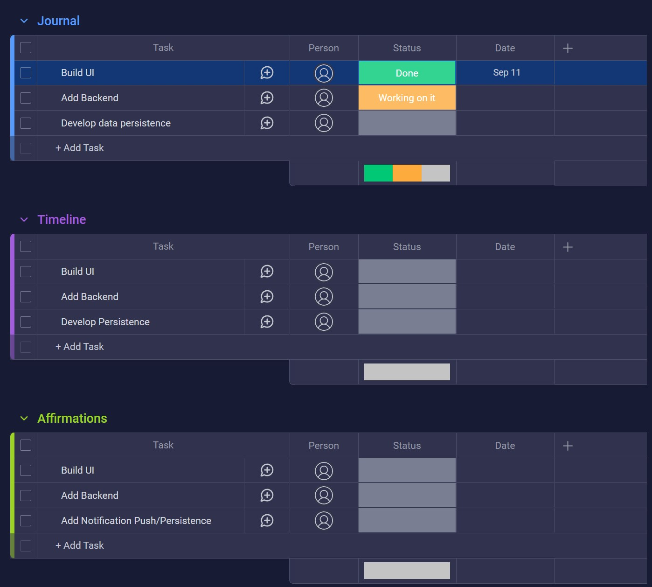  
(Due to the rushed nature of creating this, as well as the Student edition of Monday.com only allowed students a certain amount of items, I tried to keep the list limited, as to not use as much time on non-code work.)

## Github URL: [GitHub - blackabyss25/CST-451: repo for the final project](https://github.com/blackabyss25/CST-451)